EXP 05 : ONLINE COURSE REGISTRATION SYSTEM

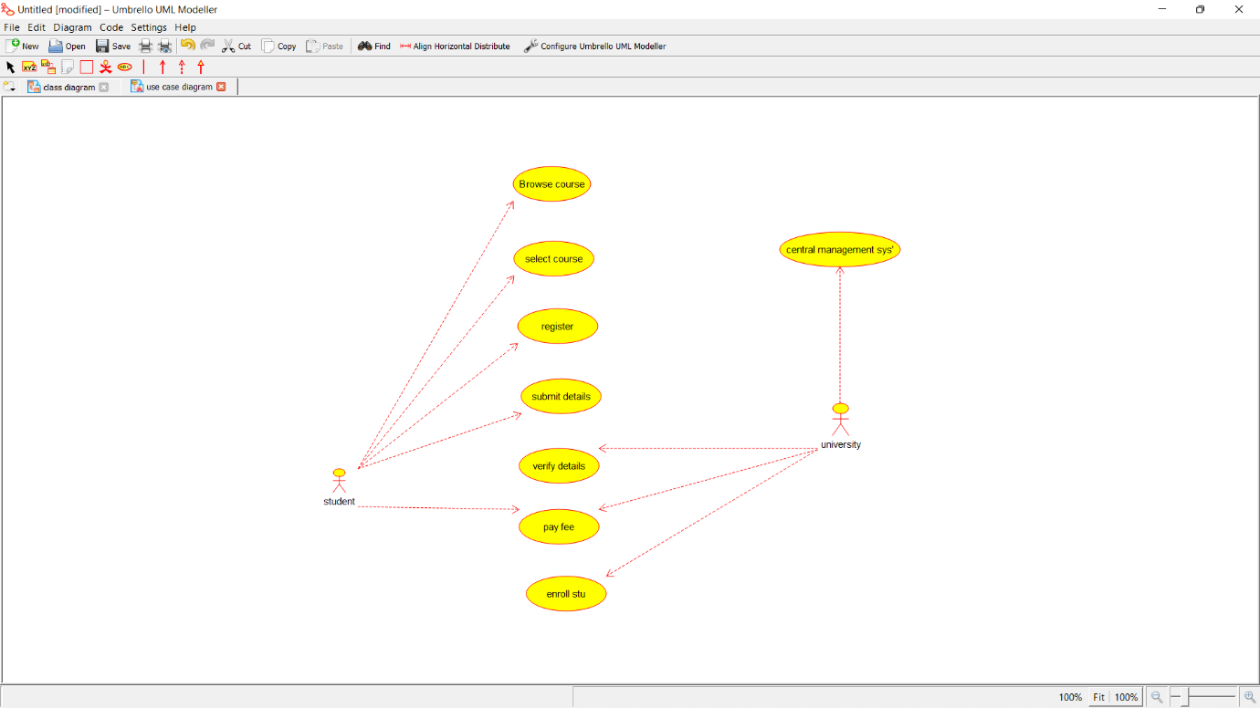

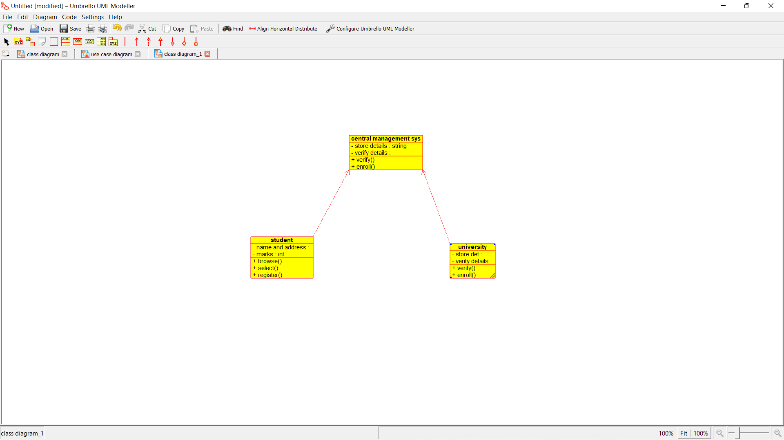

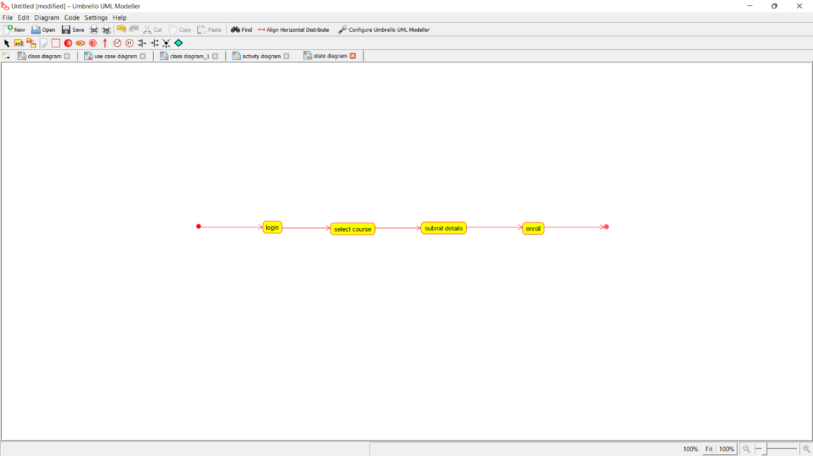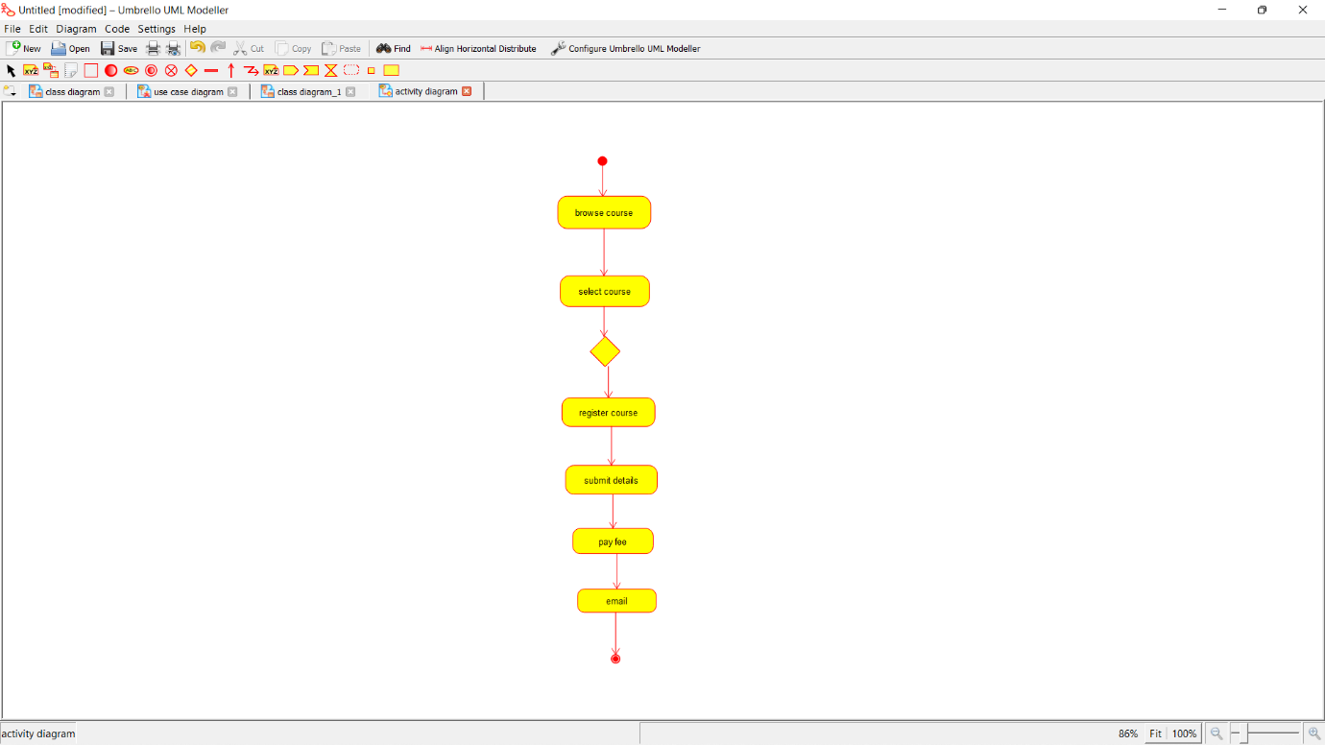

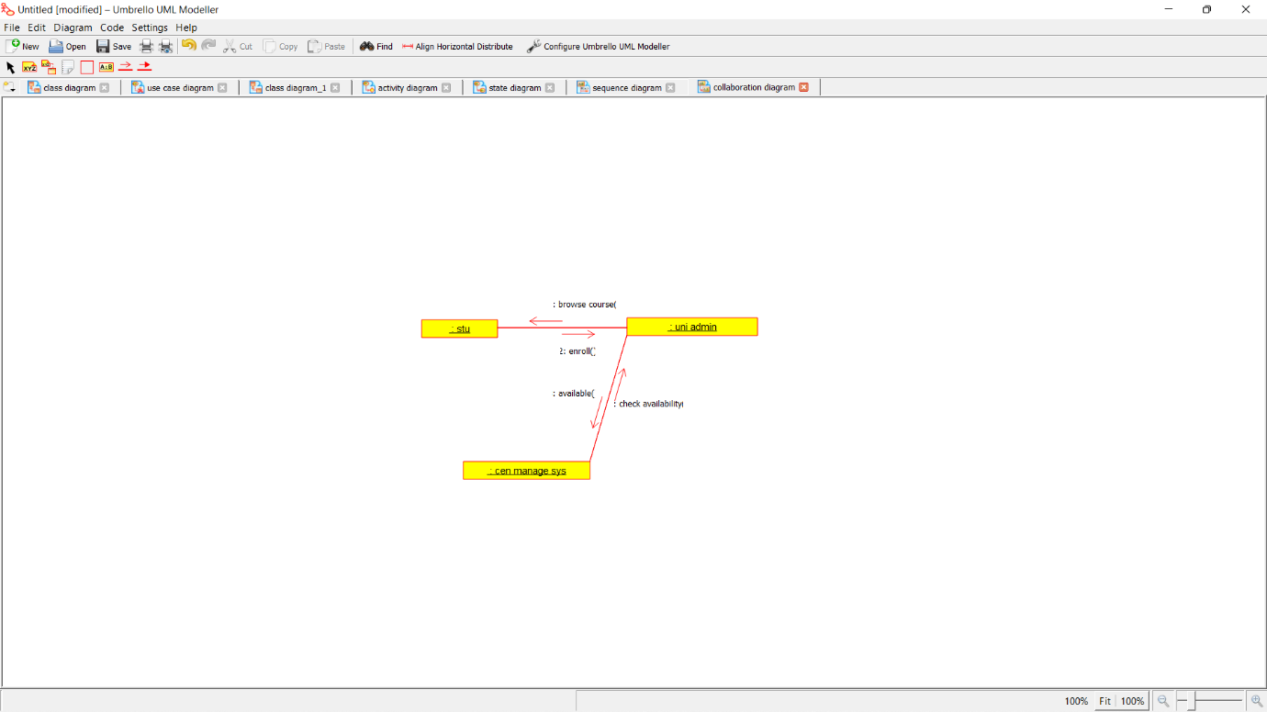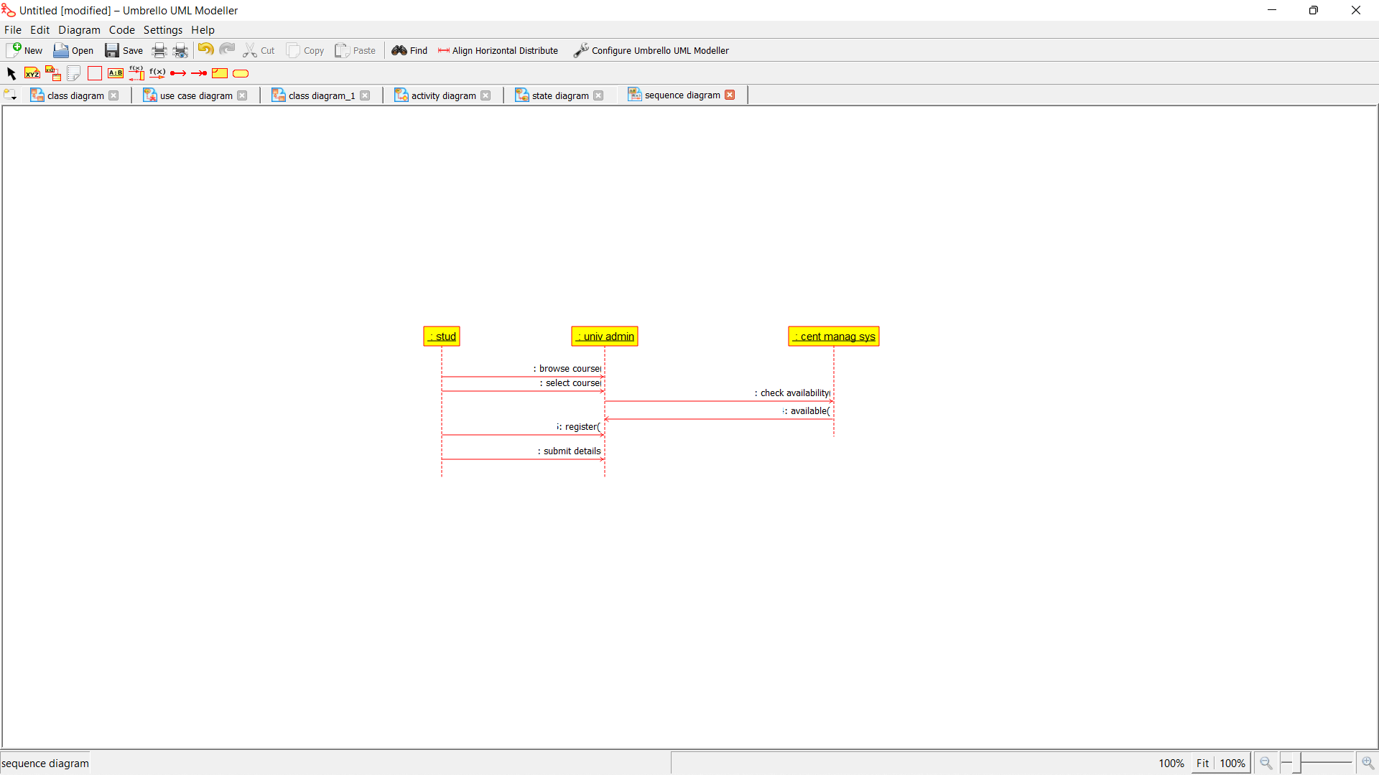

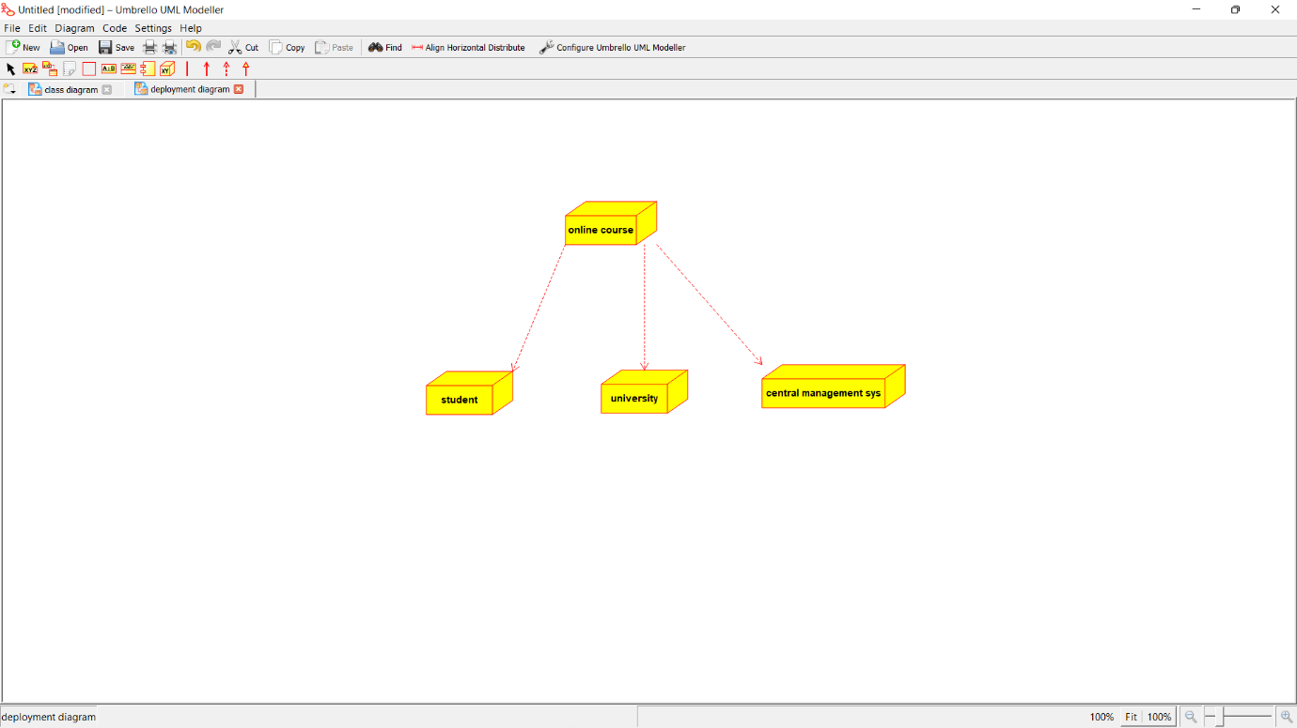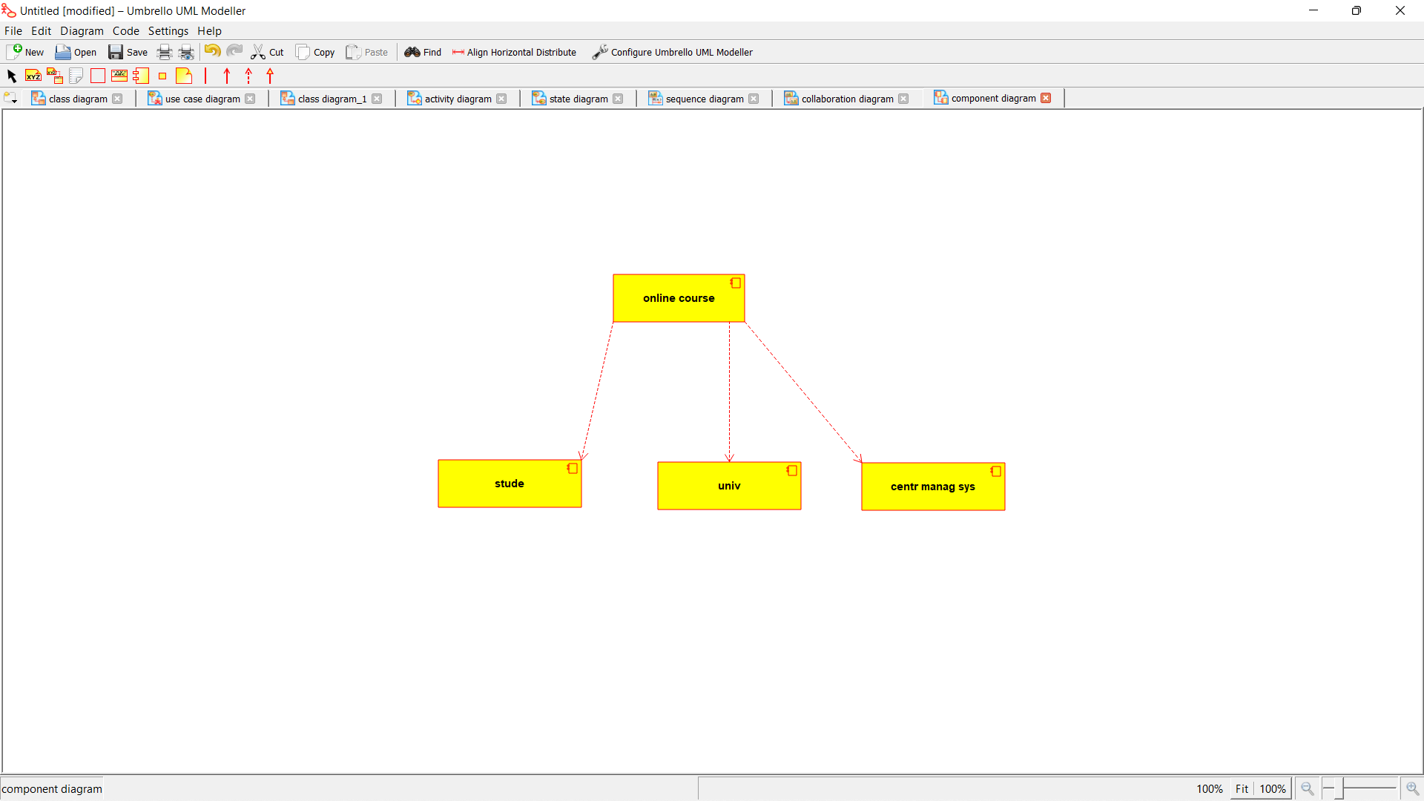

*PROGRAM CODING:*

/**

* Class Central_Management_System

*/

public class Central_Management_System {

//

// Fields

//

private String Store_Details;

private String Verify_details;

//

// Constructors

//

public Central_Management_System () { };

//

// Methods

//

//

// Accessor methods

//

/**

* Set the value of Store_Details

* @param newVar the new value of Store_Details

*/

private void setStore_Details (String newVar) {

Store_Details = newVar;

}

/**

* Get the value of Store_Details

* @return the value of Store_Details

*/

private String getStore_Details () {

return Store_Details;

}

/**

* Set the value of Verify_details

* @param newVar the new value of Verify_details

*/

private void setVerify_details (String newVar) {

Verify_details = newVar;

}

/**

* Get the value of Verify_details

* @return the value of Verify_details

*/

private String getVerify_details () {

return Verify_details;

}

//

// Other methods

//

/**

*/

public void Verify()

{

}

/**

*/

public void Enroll()

{

}

}

/**

* Class Student

*/

public class Student {

//

// Fields

//

private String Name_and_address;

private int Marks;

//

// Constructors

//

public Student () { };

//

// Methods

//

//

// Accessor methods

//

/**

* Set the value of Name_and_address

* @param newVar the new value of Name_and_address

*/

private void setName_and_address (String newVar) {

Name_and_address = newVar;

}

/**

* Get the value of Name_and_address

* @return the value of Name_and_address

*/

private String getName_and_address () {

return Name_and_address;

}

/**

* Set the value of Marks

* @param newVar the new value of Marks

*/

private void setMarks (int newVar) {

Marks = newVar;

}

/**

* Get the value of Marks

* @return the value of Marks

*/

private int getMarks () {

return Marks;

}

//

// Other methods

//

/**

*/

public void Browse()

{

}

/**

*/

public void Select()

{

}

/**

*/

public void Register()

{

}

}

/**

* Class University

*/

public class University {

//

// Fields

//

private String Store_details;

private String Verify_Details;

//

// Constructors

//

public University () { };

//

// Methods

//

//

// Accessor methods

//

/**

* Set the value of Store_details

* @param newVar the new value of Store_details

*/

private void setStore_details (String newVar) {

Store_details = newVar;

}

/**

* Get the value of Store_details

* @return the value of Store_details

*/

private String getStore_details () {

return Store_details;

}

/**

* Set the value of Verify_Details

* @param newVar the new value of Verify_Details

*/

private void setVerify_Details (String newVar) {

Verify_Details = newVar;

}

/**

* Get the value of Verify_Details

* @return the value of Verify_Details

*/

private String getVerify_Details () {

return Verify_Details;

}

//

// Other methods

//

/**

*/

public void Verify()

{

}

/**

*/

public void Enroll()

{

}

}